CRIMP

User Guide

How to use

# Standard work flow

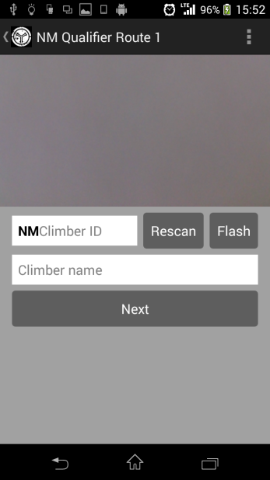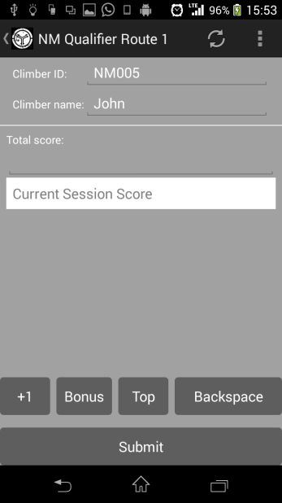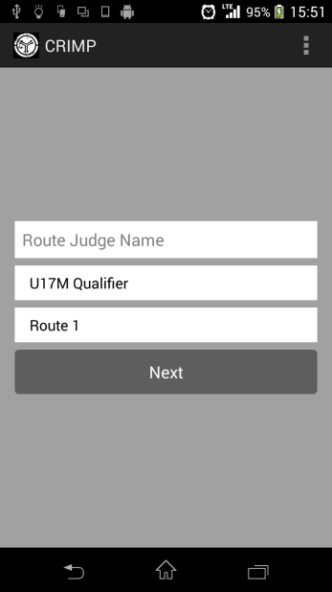

Screen 2

Screen 3

Screen 1

Screen 1, 2 and 3 will be the main screens that you will use most of the time for route judging.

# First time using

You will need to set the server password for CRIMP to communicate with the server. You will only have to do this once. Go through this same process again when the server password changes.

1) Access the setting at top right corner of CRIMP.

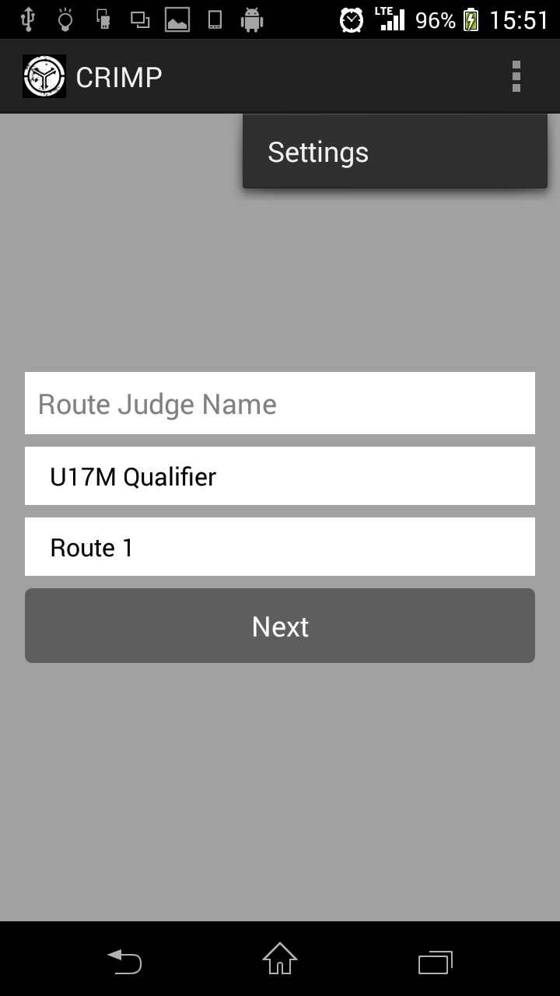

2) Click on server password to enter the password.

3) Click Ok.

# Screen 1

|  |
| --- |
| 1) Reveal additional actions (e.g. Settings). |
| 2*) Enter your name. |
| 3) Select the correct category (e.g. NM Qualifier). |
| 4) Select the route that you are currently judging. |
| 5) Proceed to Screen 2. |
| * Compulsory fields |

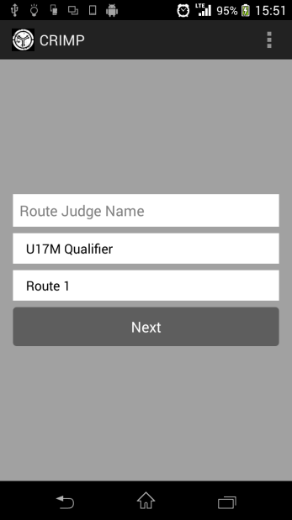

1

2

3

4

5

# Screen 2

|  |
| --- |
| 1) Category and route information. |
| 2) Reveal additional actions (e.g. Settings). |
| 3) Camera preview screen. Shows camera output. |
| 4*) Enter Climber ID (E.g. 001). |
| 5) Start the camera. Camera is usually started automatically. If for some reasons (3) is not showing camera output, click this button to start displaying camera output. |
| 6) Toggle torch light. |
| 7) Displays climber name. This field is NOT editable and you do not have to fill it. It will automatically display climber’s name when you scan climber’s QR code. |
| 8) Go to screen 3. |
| * Compulsory fields |

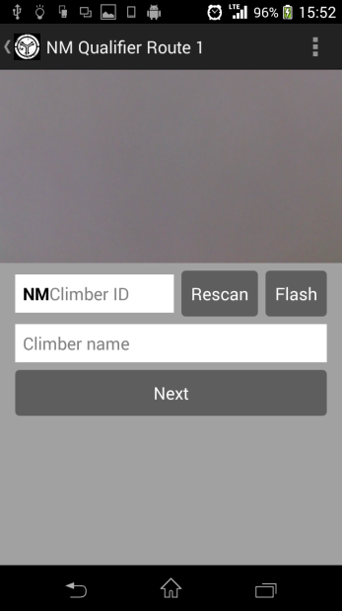

1

2

3

4

5

6

7

8

## QR scanning

1) When you first arrive at screen 2, the camera will start scanning for QR codes.

2) Align the QR code such that the entire QR code can be seen in camera preview screen.

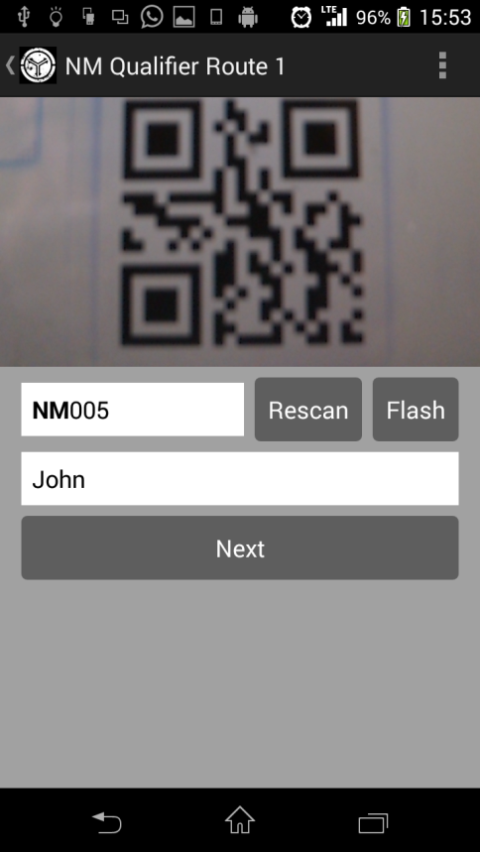

Figure QR code detected

3) QR code should be detected immediately. Preview screen will freeze and scanning will stop. Climbers information will appear on screen. To start scanning a new QR code, press Rescan button.

4) If QR code scanning is not working, you may enter the Climber ID manually.

# Screen 3

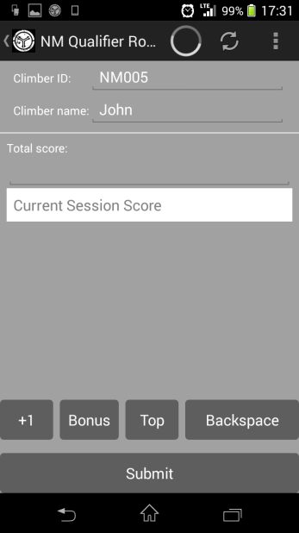

1

2

3

4

5

6

7

8

9

10

|  |
| --- |
| 1) Category and route information. |
| 2) Loading ring. Indicates that CRIMP is receiving data from server. |
| 3) Refresh button. Click to refresh the climber name and total score information. |
| 4) Reveal additional actions (e.g. Settings). |
| 5) Climber ID. |
| 6) Climber Name. Optional field. |
| 7) Display the climber’s score so far. This is optional. |
| 8) Display the climber’s score for this session. |
| 9) Buttons to edit score for this session. |
| 10) Submit score to server and return to screen 2. |

## Example:

1) You are the route judge for NM qualifier route 2. John has already taken 4 attempts at NM qualifier route 2 without getting any bonus or top. Score [1111].

2) John came up to you to attempt route 2 again. You scanned John’s QR code and arrive at screen 3.

<Session begins>  
3) Total score should display [1111].

Note: Total score provides additional information for you as route judge. In the event that total score is unavailable, it will not affect the route judging process.

4) John took two attempts and gotten a bonus and nothing in this order. You pressed the respective button and current session score should display [B1].

5) John stopped climbing. You submit the score before you let the next climber begins.

<Session ends>

6) The next time John begins a session on route 2, the total score should display [1111B1].